Project Sales

The sales data was taken from a local business. The data came from sales that occurred during 2014 to 2018.

I had to retrieve the data using a query UI built in-house, and then I used Excel to calculate sales and percentages from the data.

This project began with a simple chart to view sales overtime.

What this data managed to accomplish was to identify client types and anticipated sales per client type. This was then used to score each Client Account Manager’s (CAM) portfolio and to re-assign one client type (D) from each to new in-house CAM’s.

In the beginning “Client” represented all client types. In the end the taxonomy of “Client” became:

|  |  |  |
| --- | --- | --- |
| Client Type | Number of sale events each year | Anticipated Sales per Event |
| A | 48 | $100,000 |
| B | 12 | $30,000 |
| C | 12 | $15,000 |
| D | 2 | $10,000 |

The color coding on the map represents the mixture of new clients and existing client sales for the month. The darker the color the higher the mix of existing client’s vs new clients selling in that period.

Using R Studio I retrieved the following:

|  |
| --- |
| > library(readxl)  > Sales_Data <- read_excel("Projects/Sales/Sales_Data.xlsx")  > View(Sales_Data)  > glimpse(Sales_Data)  Observations: 60  Variables: 9  $ Year <dbl> 2014, 2014, 2014, 2014, 2014, 2014, 2014, 2014, 2014...  $ Month <chr> "JAN", "FEB", "MAR", "APR", "MAY", "JUN", "JUL", "AU...  $ Sales <dbl> 9683117, 11943025, 13304480, 15379253, 16194897, 123...  $ Num_Items_Sold <dbl> 9320, 10853, 11225, 10927, 12867, 10817, 11663, 1184...  $ Dollar_Per_Item <dbl> 1038.961, 1100.435, 1185.254, 1407.454, 1258.638, 11...  $ Num_Clients_Selling <dbl> 919, 1072, 1122, 1199, 1224, 1062, 1121, 1131, 1145,...  $ Dollar_Per_Client <dbl> 10536.58, 11140.88, 11857.83, 12826.73, 13231.12, 11...  $ Total_Clients <dbl> 4036, 4117, 4188, 4293, 4382, 4462, 4542, 4610, 4712...  $ `Percent_Clients_ Selling` <dbl> 0.2277007, 0.2603838, 0.2679083, 0.2792919, 0.279324...  Using Rattle, I retrieved the following:    Distribution of sales by month:    Distribution of the number of clients selling and the total clients at the time |
|  |
|  |

Looking at the same information, you see looking at this histogram the number of clients selling and number of clients onboarded consistently rise.

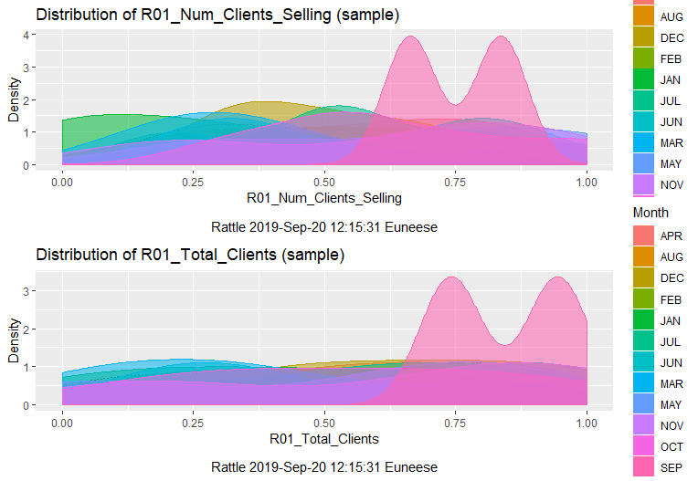



The dollar assigned per client selling drastically changes. We found that there were certain times throughout the year that agencies sold heavy equipment which brought a higher price per item.

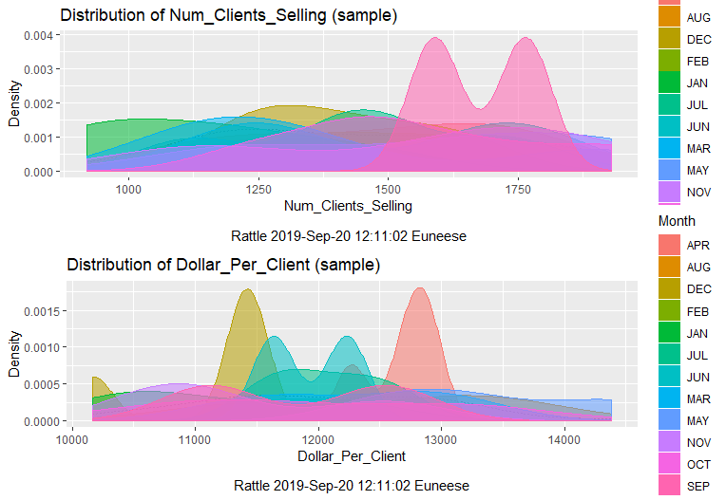

Year-over-year, looking at the percent of clients selling vs total client, it seems that the company peaked in 2016

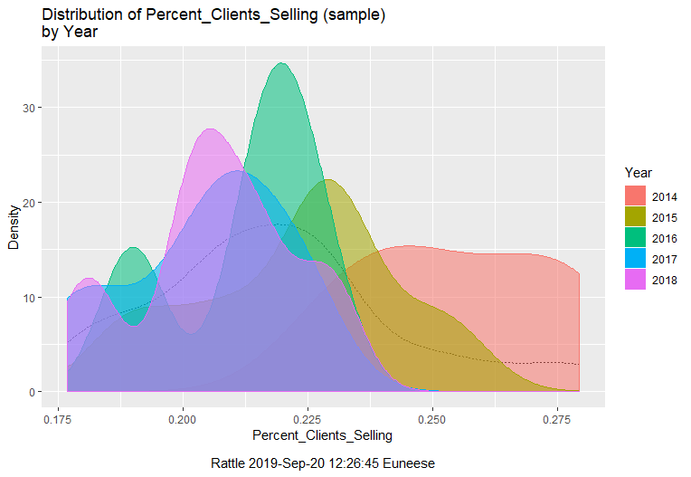

In addition, even though new clients were onboarded, it appears that the company had fewer active clients during 2015, 2016, and 2018.

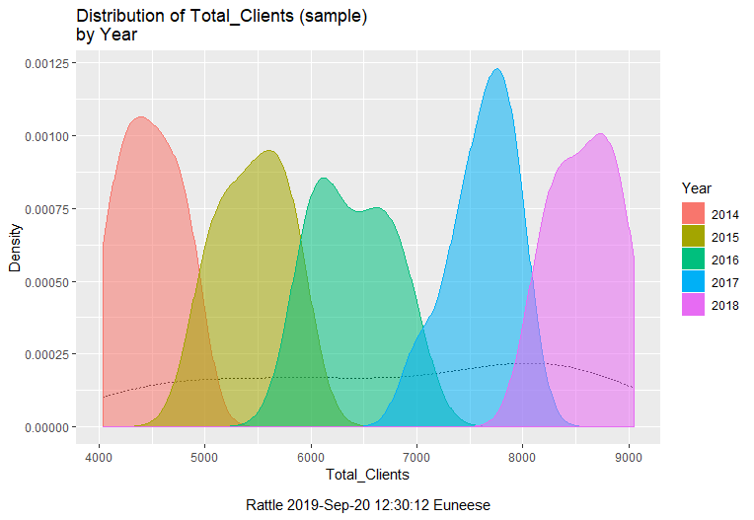

After looking at this chart, it was identified that in 2015 there were fewer clients identified as type A selling.

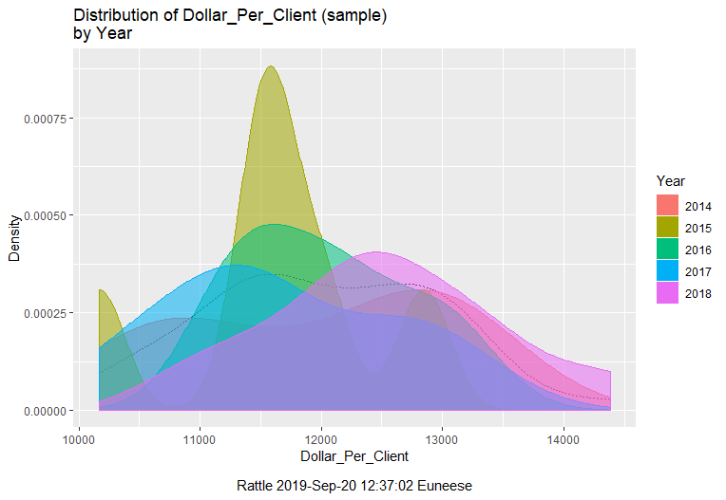

Using ggraptR we see that even though the number of clients onboarded increases, the number actively selling decreases:

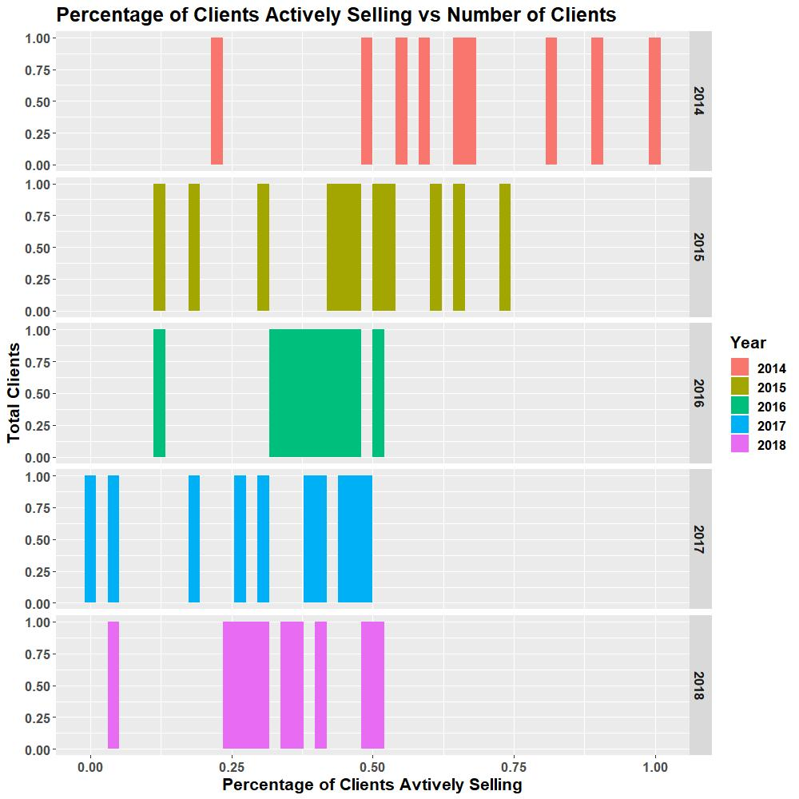

Sales Year over Year, Month over Month using ggraptR

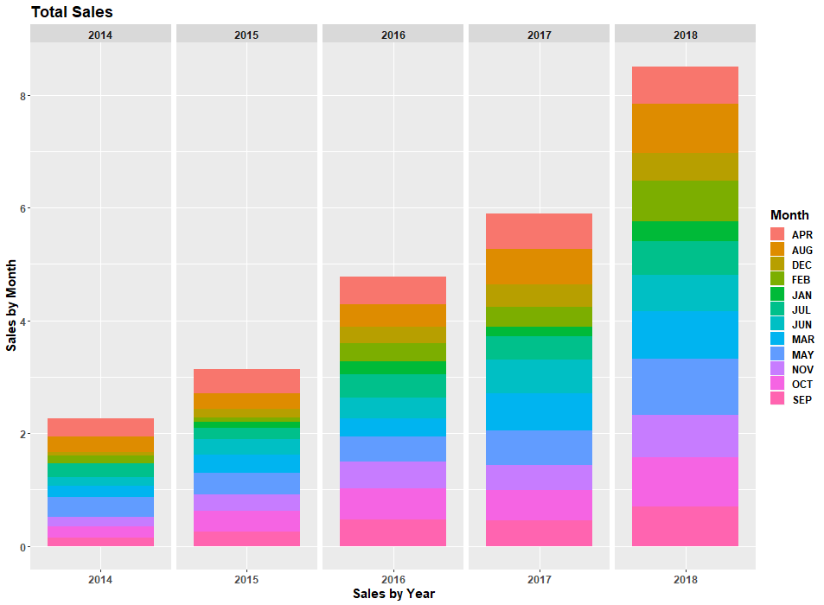

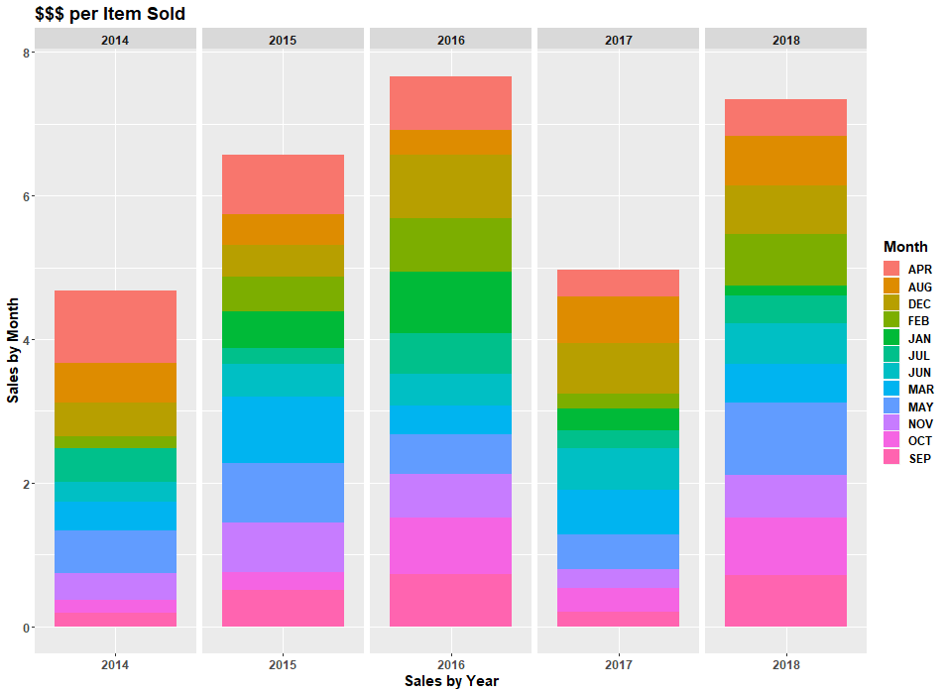

Dashboard built using Excel

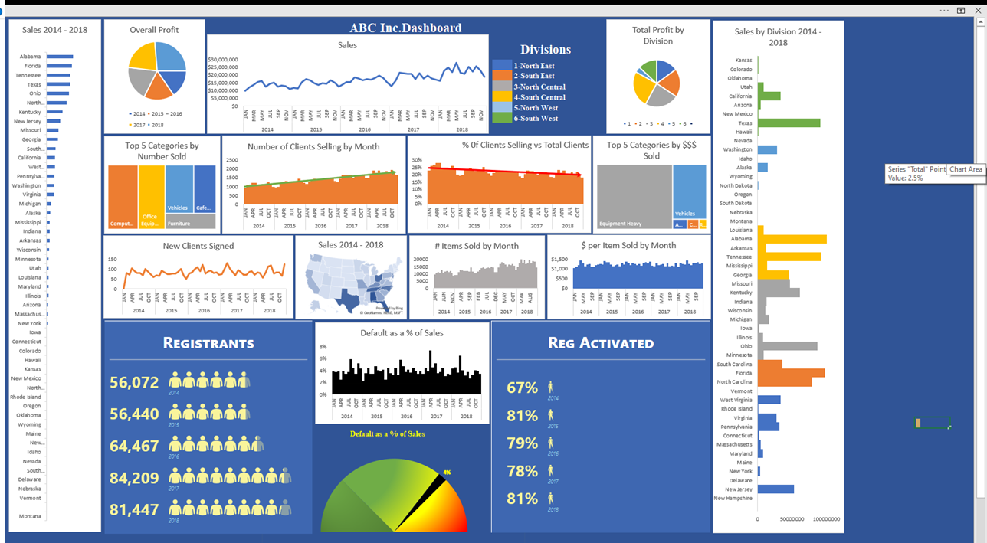

Sales data in motion using Tableau

Dashboard built in PowerBI

Client type classification and portfolio